**ASSIGNMENT 9 – W3D1 – LESSON10 – Introduction to MongoDB:**

1. **First, using the tutorial document/guide provided, obtain and install the latest version of MongoDB Community Edition on your local machine.**
2. **Create a new Database named, MyLibraryBooks-DB**

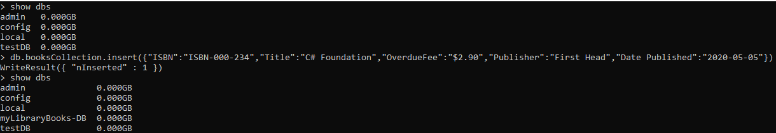

1. **In the database, create a Collection named, booksCollection**



1. **Populate the booksCollection with the following data:**
2. **Write and execute a query to display all the documents in the booksCollection (include code to make the result be displayed in a readable JSON format).**

db.booksCollection.find({"ISBN":"978-0135166307"}).pretty()

{

"_id" : ObjectId("61094c49504968a0e89c0f5a"),

"ISBN" : "978-0135166307",

"Title" : "Core Java Fundamentals",

"OverdueFee" : "$1.75",

"Publisher" : "Pearson",

"Date Published" : "2018-08-27"

}

> db.booksCollection.find().pretty()

{

"_id" : ObjectId("610948d3504968a0e89c0f59"),

"ISBN" : "ISBN-000-234",

"Title" : "C# Foundation",

"OverdueFee" : "$2.90",

"Publisher" : "First Head",

"Date Published" : "2020-05-05"

}

{

"_id" : ObjectId("61094c49504968a0e89c0f5a"),

"ISBN" : "978-0135166307",

"Title" : "Core Java Fundamentals",

"OverdueFee" : "$1.75",

"Publisher" : "Pearson",

"Date Published" : "2018-08-27"

},

{

"_id" : ObjectId("61094d8b504968a0e89c0f5b"),

"ISBN" : "978-0321714114",

"Title" : "C++ Primer",

"OverdueFee" : "$9.99",

"Publisher" : "Stanley B. Lipmann",

"Date Published" : "2019-08-08"

},

{

"_id" : ObjectId("61094daf504968a0e89c0f5c"),

"ISBN" : "1234534",

"Title" : "Dagmay Fetene",

"OverdueFee" : "$50.00",

"Publisher" : "Dr Kibreab Kibrewosen",

"Date Published" : "1999-02-04"

},

{

"_id" : ObjectId("61094db8504968a0e89c0f5d"),

"ISBN" : "978-0073523323",

"Title" : "Database System Concept 6th Edition",

"OverdueFee" : "$1.47",

"Publisher" : "MC-Graw Hill",

"Date Published" : "2011-05-19"

},

{

"_id" : ObjectId("61094dc1504968a0e89c0f5e"),

"ISBN" : "12345",

"Title" : "Design Patterns",

"OverdueFee" : "$45.80",

"Publisher" : "Publisher1",

"Date Published" : "2020-05-08"

},

{

"_id" : ObjectId("61094dcc504968a0e89c0f5f"),

"ISBN" : "123-45677891",

"Title" : "Getch Book Edited",

"OverdueFee" : "$3.00",

"Publisher" : "Longman",

"Date Published" : "2019-05-06"

},

{

"_id" : ObjectId("61094dd8504968a0e89c0f60"),

"ISBN" : "21312423535",

"Title" : "GodFather",

"OverdueFee" : "$4.00",

"Publisher" : "ARA",

"Date Published" : "1870-06-13"

},

{

"_id" : ObjectId("61094de1504968a0e89c0f61"),

"ISBN" : "978-0135974488",

"Title" : "Hacker Cookbook",

"OverdueFee" : "$10.00",

"Publisher" : "TopSecurity",

"Date Published" : "2020-05-01"

},

{

"_id" : ObjectId("61094de9504968a0e89c0f62"),

"ISBN" : "1234-121210",

"Title" : "Harry Potter",

"OverdueFee" : "$0.00",

"Publisher" : "Habtom W. Michael",

"Date Published" : "null"

}

1. **Write and execute a query to display the document(s) in the booksCollection where ISBN is “978-0135166307”.**

db.booksCollection.find({"ISBN":"978-0135166307"}).pretty()

{

"_id" : ObjectId("61094c49504968a0e89c0f5a"),

"ISBN" : "978-0135166307",

"Title" : "Core Java Fundamentals",

"OverdueFee" : "$1.75",

"Publisher" : "Pearson",

"Date Published" : "2018-08-27"

}

1. **Write and execute a command to update/change the Book Title of the Book whose ISBN is “978-0321714114” from “C++ Primer” to “C++ Primer, 2nd E**dition”.

db.booksCollection.updateOne({"ISBN":"978-0321714114"},{$set:{"Title":"C++ Primer, 2nd Edition"}})

{ "acknowledged" : true, "matchedCount" : 1, "modifiedCount" : 1 }

1. **Write and execute a command to delete the Book whose ISBN is “1234-121210”.**

db.booksCollection.deleteOne({"ISBN":"1234-121210"})

{ "acknowledged" : true, "deletedCount" : 1 }

**//-- The End --//**